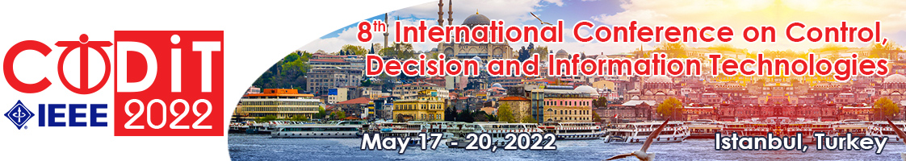
CALL FOR PAPERS - SPECIAL SESSION
“Special Session Title”
for CODIT’22
May 17-20, 2022 ▪ Istanbul, Turkey
Session Co-Chairs:
Prof. Mehdi Toloo, Technical University of Ostrava, Czech Republic (email : email1@domain.xx)
Prof. Enrique H. Viedma, University of Granada, Spain (email : email2@domain.xx)
Prof. Giuseppe Franzè, Università della Calabria, Italy - (email : email3@domain.xx)

Session description
This special session deals with the problem of …………………………………………………...................…………
…………………………………………………………………………………………………………………………………………………………………………………………………………………………………………………………………………………………
The goal is to…..............………………………………………………………………………………………………………………… …………………………………………………………………………………………………………………………………………………………………………………………………………………………………………………………………………………………………………
The topics of interest include, but are not limited to:
- …
- …
- …

SUBMISSION
Papers must be submitted electronically for peer review through PaperCept by January 07, 2022 :
http://controls.papercept.net/conferences/scripts/start.pl. In PaperCept, click on the CoDIT 2022 link “Submit a Contribution to CoDIT 2022” and follow the steps.
IMPORTANT: All papers must be written in English and should describe original work. The length of the paper is limited to a maximum of 6 pages (in the standard IEEE conference double column format).
DEADLINES
January 07, 2022: deadline for paper submission
March 4, 2022: notification of acceptance/reject
March 30, 2022: deadline for final paper and registration

